https://thestrayferret.co.uk/starbeck-special-needs-school-given-new-sixth-form-building/
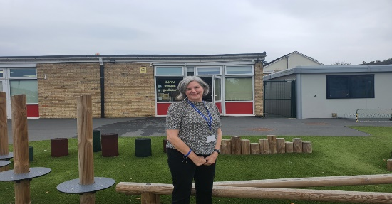 | Starbeck special needs school given new sixth form building - The Stray Ferret  A special needs school in Starbeck has refurbished a former children’s centre over the road into two new sixth form classrooms. Springwater School, which offers a modified curriculum for young people aged two to 19 with mainly multiple needs, was given the disused building by North Yorkshire County Council.. The school has grown rapidly in recent years.  thestrayferret.co.uk

