Monday

SESSION 1 | SESSION 2
Functional literacy and numeracy  Learning outcomes  - ASDAN accreditation  Match objects to symbols letters or words.  Engage in activities relating to counting in whole numbers | Sporting activities  Learning outcomes  - ASDAN accreditation  Take part in activities that contribute to keeping themselves healthy  Take part in different sporting activities
Objective: To use your literacy and numeracy skills in shopping related tasks.  Numeracy (LIVE)  - Go into your kitchen and find 5 or more items such as a tin of beans, a bottle of juice, a loaf of bread.  - Use some paper or sticky labels to label them with price labels - 10p, 20p, 50p, £1 and £2.  - Ask your parent or carer to come to your shop and buy some items with real money – you are the shopkeeper and need to check they give you the right coins! I hope they don’t get it wrong and you have to tell them off!  - Swap round and let you parent or carer be the shop keeper – look carefully at the coins and make sure you don’t get it wrong!  - Play this shopping game.  http://www.familylearning.org.uk/money_games.html  Literacy  - Following on from the shop task I’d like you to help your adult or carer by making a shopping list. You could ask the adult to write the words for you to trace or copy or have a go yourself. There’s a tick sheet shopping list and a set of everyday shopping symbols you could cut and stick instead.  - If you are able you might like to take your shopping list and go to the shop, or maybe help with an online shop! | Objective:  This week I have found some fab exercises you can do sitting down! Have a go and get your parent / carer to join in.  Warm up  https://www.youtube.com/watch?v=nj9NA3flLoI  Seated exercises  https://www.youtube.com/watch?v=KZfQ6IE5POs  https://www.youtube.com/watch?v=wPa5Vt-J0vY  https://www.youtube.com/watch?v=LahmXHwZS9g  Cool Down – lie down or sit in a comfy chair and relax!  https://www.youtube.com/watch?v=Aae4JSUb_K0

Tuesday

SESSION 1 | SESSION 2
Preparing food and drinks  Learning outcomes  - ASDAN accreditation  Take part in preparing a variety of snacks  Follow basic safety rules when preparing snacks. | Forest School  Learning outcomes  - To develop a sense of well being and a connection with nature and the outdoors.
Objective:  Can you make a fruit smoothie?  - Choose ether banana or strawberry (or both).  - Peel and chop the banana and take the stem bit out of the strawberry.  - Add the fruit to a blender or mash them up.  - Add milk and put the lid on.  - Either blend or shake the container.  - Pour into a cup and drink your smoothie – do you like it or not?  Send us some photos of you making your smoothie. | Objective:  Making Dens  - Use an old sheet or blanket to make a den either inside or outside in your garden.  - Use some string or pegs to secure it to a tree or chairs if you are inside.  - Put a mat or some comfy cushions inside and lie down and listen to the sounds of the birds. If you are inside you could put some bird songs onto YouTube and relax. Sometimes its nice to just pause and engage with nature and the world around us.  - You might like to have a nice hot drink in your den or sit there to have your lunch.  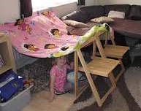  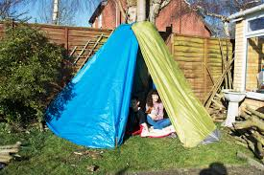
Wednesday
SESSION 1 | SESSION 2
Learning for life (Learning about the wider world  Learning outcomes  Explore the wider world and our place within it | Creative activities  Learning outcomes:  - Q Arts Award  - ASDAN accreditation  Take part in different new creative activities
Objective:  This week we are thinking about France!  Look at the PowerPoint slideshow and talk about the different aspects.  - Make a flag  - Can you prepare some cheese and French Bread. French cheese is called le fromage! I like Brie and Camembert which are French cheese. French bread is called le baguette! (Can you say these words)  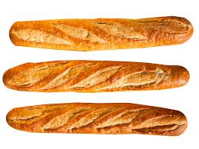  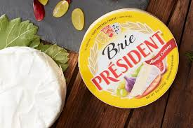  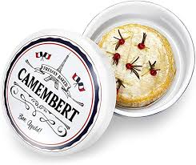  What else can you find out about France? | Objective:  Making salt dough  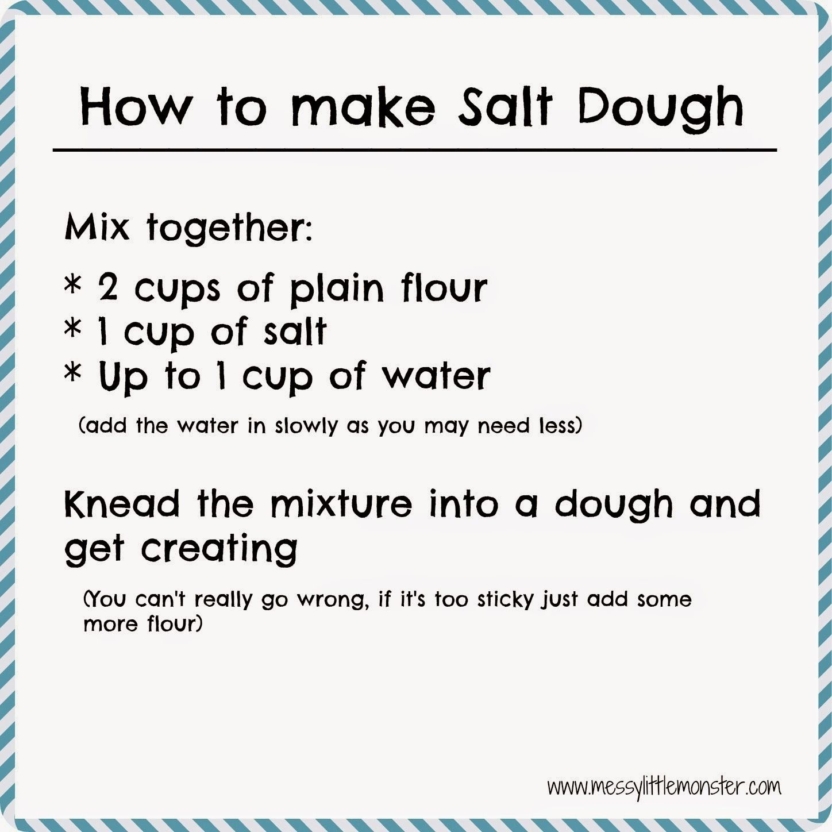  What can you make with your salt dough? Can you make an animal shape. Can you make a person? Can you make a snake?  Let your creations dry out for a few days and then you can paint and decorate them if you like!

Thursday
SESSION 1 | SESSION 2
Developing independent living skills: being healthy  Learning outcomes:  ASDAN accreditation  Take part in activities that contribute to keeping themselves healthy. | Caring for the environment  Learning outcomes:  - John Muir award  - ASDAN accreditation  Take part in an activity to improve their local environment
Objective:  Make a food rainbow  Having a healthy diet means eating lots of foods that are different colours.  - Use old magazines and leaflets from shops to create a food rainbow picture,  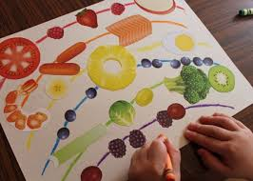  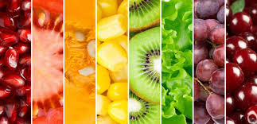  - Now try and keep a food diary for a week and write down all the foods of different colours you eat. If you have some colours you don’t eat then try and find something new to try!  (please see rainbow diary sheet) | Objective:  Recycling  Can you sort out the recycling for your house?  - Which things are glass, plastic, card and paper?  - Write the words on a piece of paper or use the symbol sheet to help you.  - Try and do this without any help if you can.  - Watch this video to see what happens to our rubbish after we send it for recycling or put it in our big bins.  https://www.youtube.com/watch?v=SSIVXZrWMK4  What can you do at home to reduce, reuse, re-cycle and rethink?  Do you use plastic straws at home? Could you use metal ones instead that you can wash and use again and again? Did you know you can reduce plastic waste by using wooden toothbrushes? Maybe when you need a new toothbrush you could ask for a wooden one.  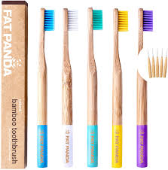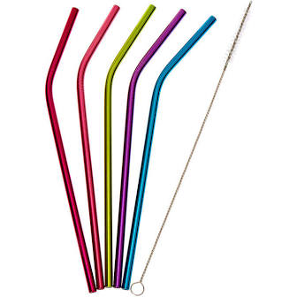
Friday
SESSION 1 | SESSION 2
Developing independent living skills: keeping safe  Learning outcomes  - ASDAN accreditation  Recognise key factors in keeping themselves safe | Headspace and mindfulness  Learning outcomes  - ASDAN accreditation  Take part in activities that contribute to keeping themselves healthy
Objective:  Can you choose the correct clothes for the weather?  Find pictures in a magazine or draw an outfit you would wear on a beach, in the rain, in the sunshine, for bed, to go running or for swimming.  Take a photo of your work and email it to your teacher.  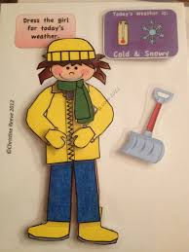  Friday is Bakery Café Day too so sit with your family and have a nice cuppa and snack – maybe do some baking too? | Objective:  Looking after our mental wellbeing is so important. I love being creative and that helps me relax and feel happy and calm.  I keep a journal and in it I draw pictures about things I like, print photos to put in it, write lists of things that make me happy and good things that have happened. But sometimes if I am sad or cross I use my journal to write it down too and this helps me work out how to feel happier again. Its good to share our feelings.  Can you draw a picture of things that make you happy or take a photo of you doing your favourite thing. Can you also think about anything that makes you feel sad and draw or paint a picture too. Then talk to your parent or carer about it and work out ways to feel more positive?  You can share your feelings pictures with your teacher if you are happy to do so.  