Monday

SESSION 1 | SESSION 2
Functional literacy and numeracy  Learning outcomes  - ASDAN accreditation  Developing ICT skills  Gain information through ICT  Early Maths: sequencing and sorting.  Recognise aspects of a sequence.  Engage in sorting data. | Sporting activities  Learning outcomes  - ASDAN accreditation  Participating in Sporting Activities  Take part in activities that contribute to keeping themselves healthy  Take part in different sporting activities
Objective: To find information about the USA presidents using a computer or tablet and present to your family what you have found out.  Literacy / ICT  Use your computer or tablet to research information about American Presidents.  Can you find a picture of them and copy and paste it into a word document?  Can you find out the last 5 presidents names and type them into your word document?  Can you find out when they were in office?  If you are using a tablet you could take a screenshot of the information instead!  We also need a photo of you doing your work on the computer please.  PLEASE SEND this document to shudson@springwater.n-yorks.sch.uk as this work will be collected towards your young person’s ASDAN accreditation – we still want them to achieve these qualifications despite working from home!  Objective: Sort your odd sock pile into pairs  Numeracy  Your task is to get all the odd socks in the house and put them into pairs of ‘the same’.  You could look at the size of the socks and put them in order of size and sort them into colours too.  Do you know who the socks belong to in your house? Can you put them in piles for that person and even better, can you put them away in the right place? | Objective: Develop your ball control skills and notice when your body has had exercise.  Watch this video about ball handling skills – we are focussing on bouncing and catching.  https://www.youtube.com/watch?v=uogIRwyNFpI&vl=en  Now you try this at home – try catch a ball someone else bounces to you, then bounce it and catch it yourself and then bounce for another person to catch.  You can try using different balls and making the distance between you greater each time.  If you get really good with this you could bounce the ball, clap and then catch it.  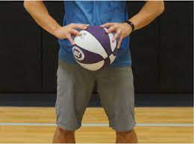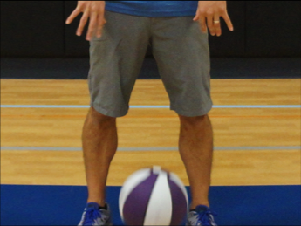
Tuesday

SESSION 1 | SESSION 2
Preparing food and drinks  Learning outcomes  - ASDAN accreditation  Take part in preparing a variety of snacks  Follow basic safety rules when preparing snacks. | Forest School / (Developing independent living skills: Keeping safe)  Learning outcomes  - ASDAN accreditation  Follow simple safety routines  Personal wellbeing.
Objective:  To use a toaster and pan on the hob safely.  Your task today is to remember how to make toast independently and to use a pan on your cooker hob to warm some beans or spaghetti safely.  Cut and stick the instructions symbols in the correct order to help.  Can you answer the following questions?  - What do you need to do first?  - What is dangerous? How can you keep yourself safe?  - What do you need to remember to do when you have finished?  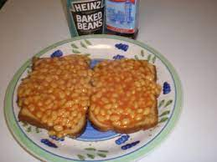 | Objective:  To use a potato peeler safely to whittle wood.  Firstly, you need to find a range of sticks - so get outside in your garden or go for a walk to collect some different ones.  To use a potato peeler to whittle the bark off a stick. Hold the stick in one hand and move the peeler away from your body. If you have different potato peelers in your house then have a go with them all to see which you find most comfortable. Using the peeler is a lovely activity but if you want when you have taken all the bark off you could decorate your stick with pens and paints.  https://www.youtube.com/watch?v=wzlKsA-HRPI  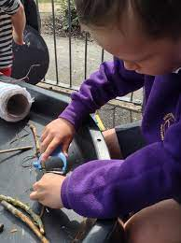  You could hang your sticks up from a tree like wind chimes!

Wednesday
SESSION 1 | SESSION 2
Learning for life (Learning about the wider world  Learning outcomes  Explore the wider world and our place within it | Creative activities  Learning outcomes:  - ASDAN accreditation  - Take part in different new musical activities
Objective: To find out 5 new things about Greece.  This week we are thinking about Greece.  Look at the PowerPoint slideshow and talk about the different aspects.  What else can you find out about Greece? | Objective: Draw in response to different genres of music and talk about what the music made you feel like.  Listen to these 3 very different genres or types of music. Whilst you are listening to them draw a picture, draw whatever you feel like while listening to the music.  https://www.youtube.com/watch?v=nkqnuxKj8Dk&list=RDQMqXacODMpY6E&start_radio=1  https://www.youtube.com/watch?v=lxiI8G0IDY4  https://www.youtube.com/watch?v=kZHfmgIb4mc

Thursday
SESSION 1 | SESSION 2
Developing independent living skills: being healthy  Shop, Cook, Eat  Learning outcomes:  ASDAN accreditation  Take part in activities that contribute to keeping themselves healthy. | Caring for the environment / Growing and caring for plants.  Learning outcomes:  - ASDAN accreditation  Take part in an activity to improve their local environment
Objective: To plan, shop for and create a 2 course meal.  A 2 course meal means you either have a starter and a main course or a main course and a pudding (some of us call it a dessert).  You can choose which you are going to do.  Have a look at the menu ideas in the resources and make your 2 choices.  Write a shopping list and go shopping to buy the ingredients if you can.  Prepare your food and take some photos.  Score your meal out of 5 (1 is not so good and 5 is delicious)  Don’t forget to wash up the pots, dry them and put them all away. | Objective: To learn about air pollution and consider ways we can improve it,  Materials:  - A piece of white or clear plastic (a plastic plate is fine)  - Petroleum jelly (Vaseline)  - Duct tape  - A wood block or brick  - Blank white paper  ​Experimental Procedure:  - Coat the top of the white or clear plastic with petroleum jelly.  - Secure the plastic to a wood block, brick, or other weighted object using duct tape (this is so it doesn’t blow away).  - Identify an outdoor location that is mostly open with decent air circulation (on a fence is preferable to on the ground).  - Let the plastic/block sit for at least 24 hours (weather permitting).  - At the end of your experiment, collect the plastic/block and bring it inside. If you are using a clear piece of plastic, place it on a white piece of paper or light-coloured surface.  - Examine the top of the plastic for any particles collected and take a photo.  - OPTIONAL: Create two air pollution sensors and place them in different locations – at home/at school, indoor/outdoor. Then compare the pollution collected by each.  What did you find? What do you think this means? Send us your photos and a few words about what you found out!
Friday
SESSION 1 | SESSION 2
Developing independent living skills: keeping safe  Learning outcomes  - ASDAN accreditation  Recognise key factors in keeping themselves safe | Headspace and mindfulness  Learning outcomes  - ASDAN accreditation  Take part in activities that contribute to keeping themselves healthy.
Objective: To be able to look after your personal things when out and about.  Look at the resource sheet and select the images that would be good to carry your keys, wallet and mobile phone in if you are going out.  Think about why it might or not be a good idea to put your things in a trouser pocket etc.  Demonstrate on a walk or trip to the shop that you can remember, without being prompted, how to look after your own things.  If you go to a shop and pay for something, what do you do with your wallet when you have paid?  What would happen if you lost your keys?  How might you feel if you lost your mobile phone?  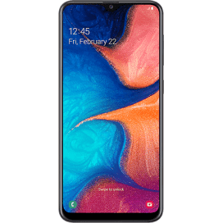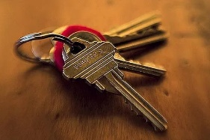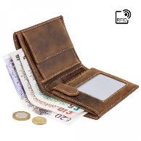 | Objective: To experience a new form of relaxation.  Binaural relaxation is said to help reduce stress, help you sleep better and improves concentration.  Binaural means that the people have used two microphones to record the music and they play each bit is played separately to your two ears.  You need to find a quiet space and lie down. You need to be really comfortable.  It is important that you wear headphones for this activity.  https://www.youtube.com/watch?v=JLcVKyABF4U  When you have finished make sure you get up slowly and allow yourself some time to focus when you open your eyes.  Your parents and carers might like to try this one as well!

