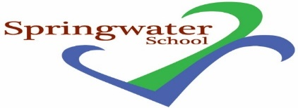

General Teaching Assistant (SEN)
posts available

Commencing as soon as possible
5 days Monday to Friday 8.45 am to 3.30 pm
31.25 hours per week
+ Ad hoc attendance at Staff Meetings – Tuesday’s 3.30 to 4.30 pm - 1 hour per month paid on supply

Part-time posts also available

TTO Plus Training days
NYC - Grade E

Springwater School is a successful and popular all-age special school catering for pupils with a wide range of challenges and needs.

The post holders will be part of a dedicated staff team, and we will provide you access to training support and professional development.

Springwater School is committed to meeting the needs of our diverse community and aim to have a workforce reflecting this diversity. We are also committed to safeguarding and promoting the welfare of our pupils and young people. We have a robust Safeguarding Policy and all staff will receive training relevant to their role at induction and throughout employment at the School. We expect all staff and volunteers to share this commitment. These posts are subject to satisfactory references and enhanced Disclosure and Barring Service criminal records check for work with children and adults. An online search may be undertaken for shortlisted candidates as part of the recruitment process on information available in the public domain. Candidates should disclose anything that may be relevant in line with Keeping Children Safe in Education.

Further details including qualifications required - minimum NVQ Level 2 qualification in supporting teaching and learning or equivalent is essential for the GTA role, and application forms are available from:

Email: hnewton@springwater.n-yorks.sch.uk

Closing date: 3 pm Thursday 12th October 2023

Interviews: Thursday 19th October 2023

Springwater School
High Street
Starbeck
Harrogate
North Yorkshire
HG2 7LW

