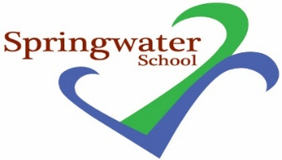

23rd March 2023

Please see below a link to a free activity in the Easter holidays. This is funded by the FEAST scheme which is open to Free school meal pupils

A great experience for your FSM families over Easter. Just wanted to make sure you had seen it and signposted to your families if suitable.
Outdoor Adventure with Base Camp - North Yorkshire Together

