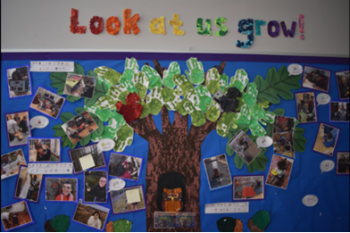

Springwater School Newsletter
Spring term 2023

Welcome to the Spring edition of our Personal Development Newsletter. This term, our students have engaged in different activities that seek to enhance their knowledge and understanding of the world around them.

Penguin Awareness Day

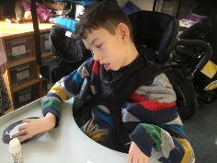
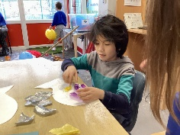
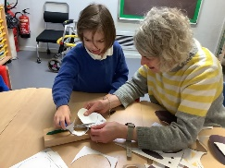
In January, our students enjoyed Penguin Awareness Week. Students learned lots about penguins and their habitats, whilst also learning how to protect them and look after our world.
Carnival Rio

In February the school celebrated Carnival Rio! Students completed lots of fun crafts; head dresses, flags and masks, before dancing their socks off to carnival music, enjoying the bright colours, loud music and showing off their fabulous dance moves.

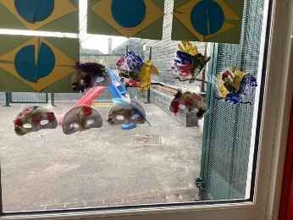
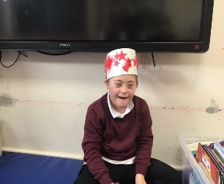
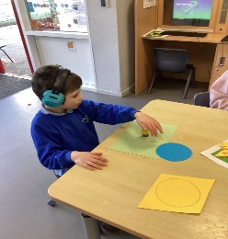

The Great Daffodil Appeal
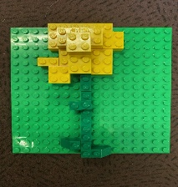
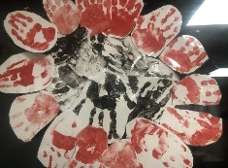
In March students across school made daffodils and learned about St. David’s day and flowers, ahead of the National Day of Reflection on March 23rd. a time when students and staff came together to remember loved ones, support people who are grieving, and connect with each other. Together we created a wall of reflection.

Special Events

As a school we encourage children to participate in special events over the term, for their enjoyment and to support mental well-being.

Love is in the air
This term sixth form students were kind enough to host a valentines disco for the whole school to enjoy, as part of their business enterprise. Students baked cakes, made treats and set up a wonderful event in the hall.
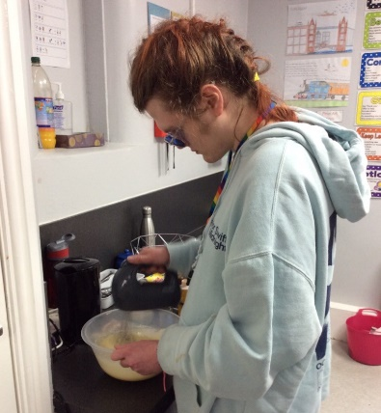
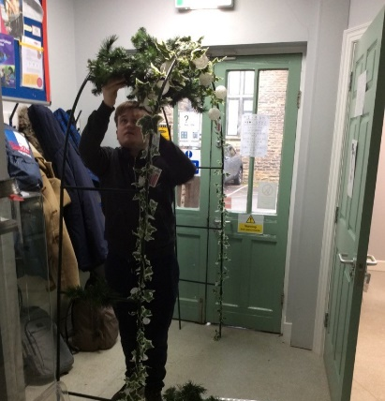
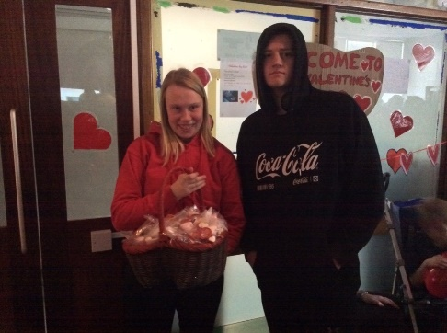

Pupils enjoyed the music and the lights and truly danced their hearts out, along to our resident DJs.
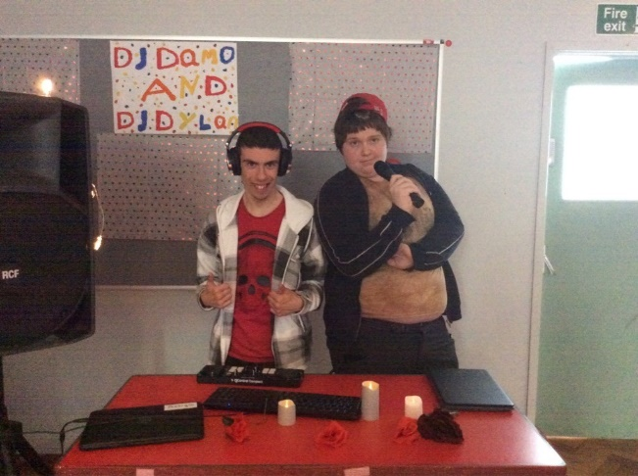

A great time was had by all and we are extremely grateful for all of the hard work of the staff and students involved. Well Done!

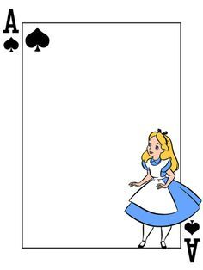

Alice in Wonderland
In February, the school had a surprise visitor - Alice!
Well, you wouldn’t believe it, but she was lost in our hall...
Except, it wasn’t our hall any more. Thanks to fabulous back drops, lights and props, out school hall had transformed into Wonderland!
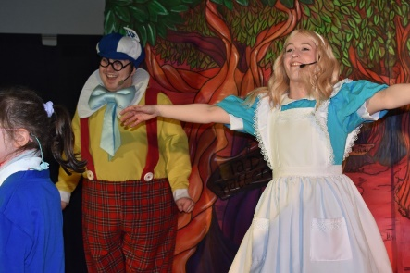
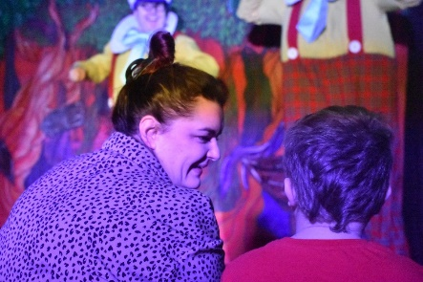
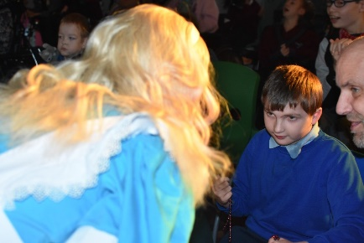
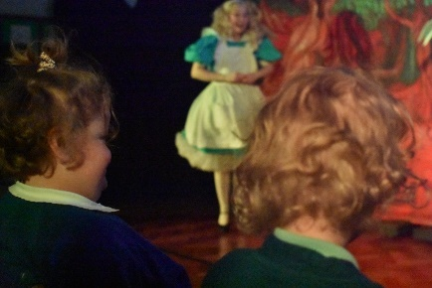
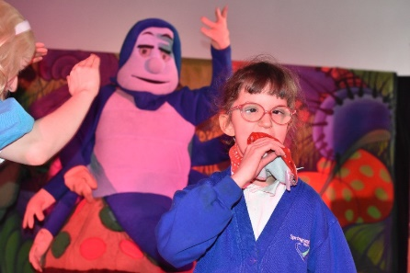
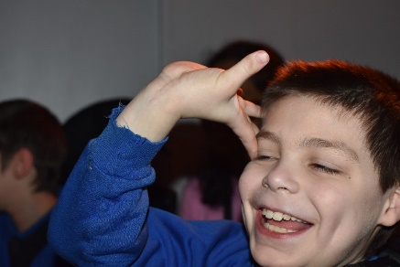
Students and Staff loved getting involved with Alice and her friends. There were lots of giggles, as well as dancing and singing.

Thank you to the wonderful actors who
embraced our students and gave
them a morning to remember!
RE Week: Buddhism

In the last week of term, we took part in our RE week. This time, we looked at Buddhism.

We created prayer flags. We attached our own prayers for things we’d like to do more of in the future, like swimming, as well as some of our big dreams!

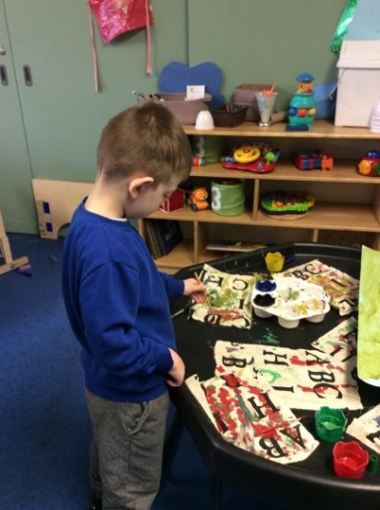
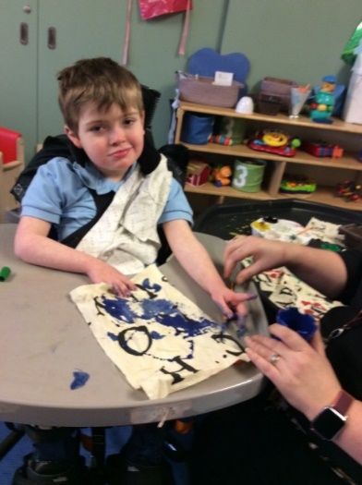
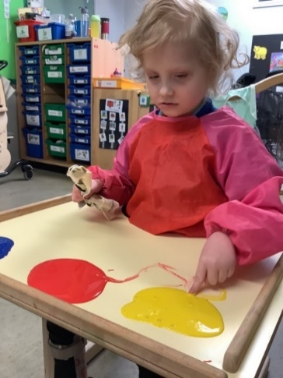

Kristina visited all of our classes and showed us some yoga poses and relaxing music, which allowed us to become mindful and calm.
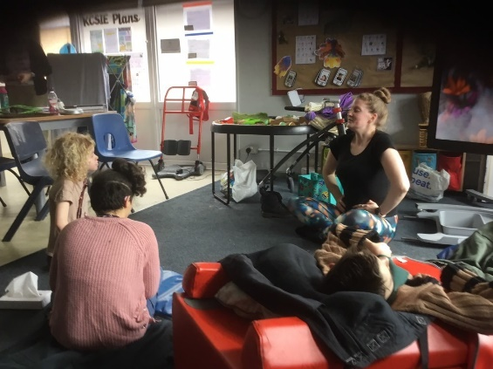

We baked lots of yummy treats and shared these in community spirit around school.

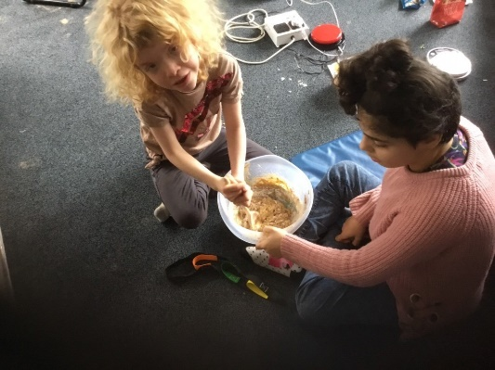

RE WEEK: BUDDHISM

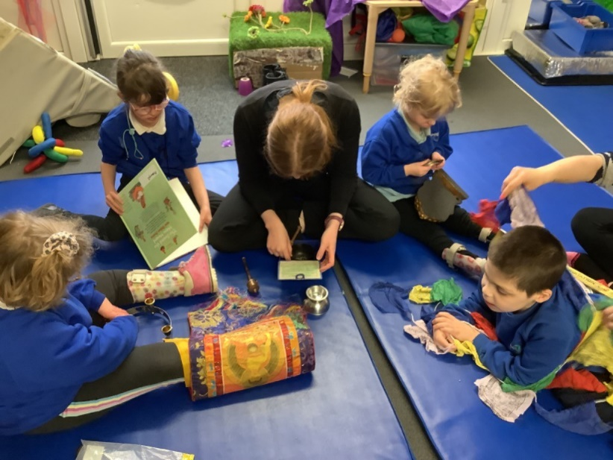
We all enjoyed a beautiful sensory story too! We looked at lots of artefacts during the story and experienced lots of visual excitement, as we explored such items as mala beads, buddha statues and incense.
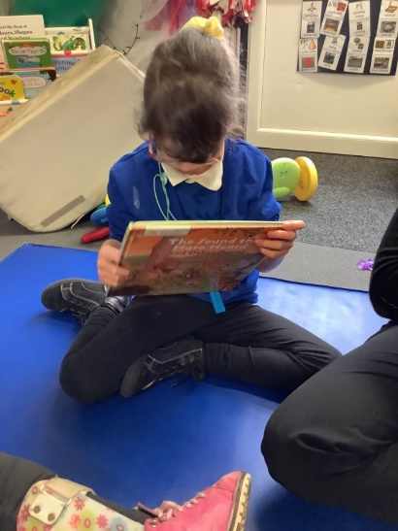

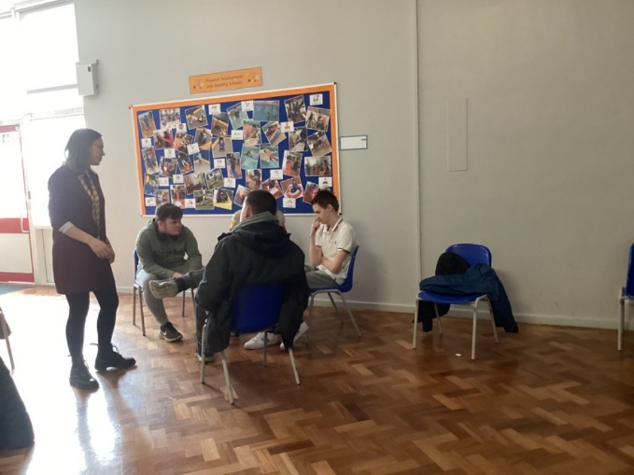
Some of us were also lucky enough to have lots of questions answered by followers of Buddhism!

Thank you, as ever, to our RE Lead Kelly, and her team for planning and setting up such a wonderful week for us all!
HOT OFF THE PRESS!

Our school Facebook page contains the most recent updates about activities and events in school.
Look out for the updates for further end of term activities.

