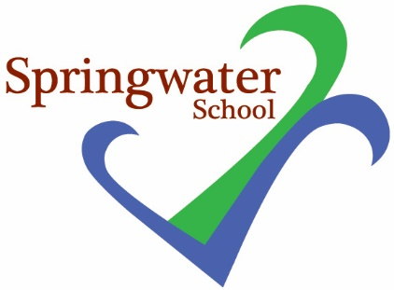

Supply
Class Teacher

Main-scale plus SEN

We are seeking to appoint on a ad hoc, supply basis, enthusiastic and committed teachers who hold appropriate qualifications and experience

Springwater School is a successful and popular all-age school catering for pupils with a wide range of challenges and needs.

Springwater School is committed to meeting the needs of our diverse community and aim to have a workforce reflecting this diversity. We are also committed to safeguarding and promoting the welfare of our pupils and young people. We have a robust Child Protection Policy and all staff will receive training relevant to their role at induction and throughout employment at the School. We expect all staff and volunteers to share this commitment. This post is subject to satisfactory references and enhanced Disclosure and Barring Service criminal records check for work with children. An online search may be undertaken for shortlisted candidates as part of the recruitment process on information available in the public domain. Candidates should disclose anything that may be relevant in line with Keeping Children Safe in Education.

If you think you possess the skills, talent and passion to join our team, we would like to hear from you. Further details and an application form are available from:
hnewton@springwater.n-yorks.sch.uk

Closing date: by 9 am Friday 10th November 2023
Interviews: wc 20th November 2023 date to be confirmed.

SPRINGWATER SCHOOL
HIGH STREET
STARBECK
HARROGATE HG2 7LW

